Process | Updation Date | Subject | Remarks | Source Mail
MLS | Wed 9/15/2021 5:49 PM | RE: Account Number Format-- Texas- Core Counties | Clay, Marion, Wilbarger, Donley, Coke, Reagen, Dickens, Loving  Short Account Number | 
HB | Mon 3/7/2022 11:20 AM | Avinash - Google sheet link | Google sheet link | 
Resi Data | Mon 3/28/2022 9:16 AM | New Enhanced Residential Data Uploading Template_2022.xlsx | Residential data uploading template | 
MLS | Mon 4/4/2022 10:45 AM | FW: TEXAS COUNTIES THAT CHANGE ACCOUNT NUMBERS | Wise county account number format has been changed as short account number without prefix | 
HB | Fri 7/22/2022 3:03 PM | RE: HB-Values Clarification | Williamson, Tom Green – Sale Mean & Median Value | 
HB | Fri 6/24/2022 4:49 PM | RE: Update/Clarification - Multiple account - Client - House Bill | Rega-the emails received from CS Agents | 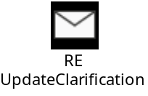
HB | Wed 7/27/2022 3:01 PM | RE: Evidence | WCAD- Adjusted sales price is the same sales price | 
MLS | Mon 8/8/2022 10:23 PM | RE: Req-MLS Logins-2022 | No business expansion efforts in these 2 states this year FL &NY | 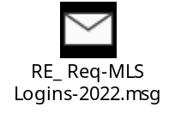
MLS | Fri 8/19/2022 12:52 PM | FW: Account Number Format Change | Washington – UT State (Short A/c) | 
MLS | Fri 8/19/2022 6:08 PM | Utah MLS Downloading | Need to download 2021-2022 Washington county Sale | 
MLS | Fri 9/9/2022 4:49 PM | FW: Waco MLS update | Waco MLS Update | 
HB | Tue 9/13/2022 12:26 PM | RE: HB-Values Clarification | Mean & Median Value – Clarification for FBCAD & Wise Cad | 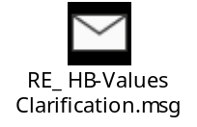
MLS | Tue 9/13/2022 12:11 PM | FW: Chicago Association of Realtors - Log-in information | Log-in information – Chicago  MLS@pconnnor.com. | 
HB | Mon 11/14/2022 3:27 PM | FW: Breaking: Dallas Central Appraisal District attacked by ransomware, agency says | Ransomware Attack – Dallas CAD | 
HB | Tue 11/29/2022 8:32 PM | RE: Update - Do not contact/cease & desist flag in Spartaxx | Procedure for the clients marked "Do not contact/cease & desist” | 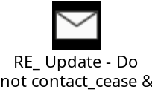
MLS | Thu 12/1/2022 9:29 AM | MLS- Henderson Change in Account Number Format | Henderson - Short Account Number | 
HB | Thu 12/8/2022 12:28 PM | FW: Promotion - Admin Ops Supervisor | Frances Martinez has been promoted to Administration Operations Supervisor | 
HB | Mon 12/12/2022 6:04 PM | FW: Spartaxx DB - Readonly Access | SPXDB - DOMODB | 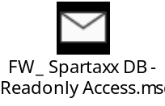
MLS | Thu 12/15/2022 5:56 PM | LUC Description | MLS -LUC Description Sheet | 
GENERAL | Wed 1/4/2023 4:51 PM | Weekly Meeting Presentation Schedule | Weekly Team Meeting PPT Presentation & MOM Schedule | 
HB | Thu 2/9/2023 6:27 PM | RE: Req-LUC Update in PaperWise-CMT Batchcode_High | Source of fetching the LUC table updated in PW | 
MLS | Mon 2/27/2023 10:37 AM | FW: Server Rename - INEDAPPS to FILEPREPAPPS | server renaming will replace the MLS web applications URL  From http://inedapps:144/ to http://fileprepapps:144/ | 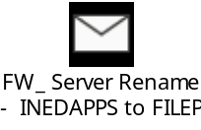
GENERAL | Fri 2/17/2023 6:09 PM | EOS - Presentation | EOS - PPT | 
HB | Mon 2/20/2023 3:28 PM | RE: HCAD House Bill Download | Login Credentials for HCAD  Link : https://agents.hcad.org/ Agent# 00463 Password# proptax12@@ | 
GENERAL | Fri 2/24/2023 10:50 AM | EOS-- Presentation- High level Overview | EOS Training Conducted by Praveen | 
GENERAL | Fri 3/3/2023 2:22 PM | FW: ED database access | renewed credentials  Username : readonlyaccess Password : readonlyaccesspwd | 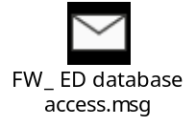
HB | Tue 3/7/2023 5:34 PM | FW: Evidence Request | Received Cad Response from Denton Password:  #DCADConfidentialSales2022 | 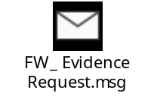
MLS | Tue 3/7/2023 10:33 AM | Appending procedure document. | Procedure document for appending | 
MLS | Fri 3/10/2023 7:36 PM | RE: Req - MLS Resivalue | Main product link :https://forms.resivalue.com/ Login MLSTesting@pathfinderanalysis.com / 123456 | 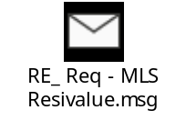
MLS | Fri 3/10/2023 1:57 PM | RE: Production Tracker for March 2023 | Target has been revised for MLS | 
MLS | Mon 3/13/2023 5:50 PM | RE: Account Number Format Sheet | Dickens, Loving, Knox, Foard – Short A/C  Robertson – Long A/c with Hyphen | 
MLS | Tue 3/14/2023 10:21 AM | RE: MLS Web Application Login Details | New Web Application Link  http://fileprepapps:144/ | 
HB | Thu 4/13/2023 12:11 PM | RE: Agent Evidence | EPCAD – Login credentials  URL : https://account.box.com/login  User name : proptax@poconnor.com  Password : Oconnor1234 | 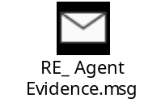
HB | Thu 4/20/2023 10:28 AM | RE: Issue - HB Extractor - HCAD House Bill Scrapping 2023 - Critical | Dtscandate SP validation  Status blank Display  Batchid Deletion | 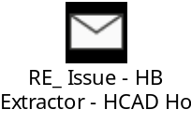
HB | Mon 4/24/2023 12:04 PM | RE: Need clarity on Cost/Income document type to process as HB | Got Confirmation to process Cost & Income doc as HB | 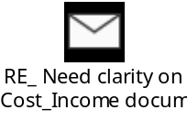
MLS | Thu 4/20/2023 3:34 PM | RE: Req - Update correct counties - High | County Name mismatch | 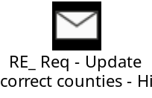
HB | Thu 4/27/2023 7:43 PM | \\SPXFPAPPS\SpxPerfUatApp\HouseBill201Evidence slowness while pasting the | attempting to place the PDF documents in the folder | 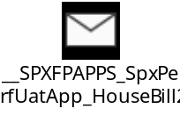
HB | Thu 5/4/2023 12:21 PM | FW: SPAM EMAILS - Be cautious | Spam Emails | 
HB | Thu 5/25/2023 4:16 PM | WCAD-NOAV-2023-OConnor.zip
HB | Wed 5/31/2023 8:45 PM | RE: House bill evidence Aransas | Aransas – Login Credentials  https://portal.trueautomation.com/86 User Name : oconnor Password: proptax1234 | 
GENERAL | Tue 6/6/2023 12:10 AM | FW: Courthousedirect.com - updated credentials | Courthousedirect Username: poconnor, Password: pfba@2023 | 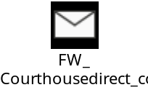
HB | Tue 6/6/2023 4:38 PM | RE: Clarification on Camp county CADID | Refer : county_Taxroll_SPX if mismatch with CAD ID | 
HB | Wed 6/14/2023 6:50 PM | RE: ShareFile Activity Notification | Housebill FBCAD – Need to check in Cluster | 
HB | Thu 6/29/2023 6:06 PM | RE: Matagorda- Sale Median value Clarification | Confirmation reg – mean & median Value | 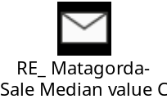
General | Sat 7/8/2023 10:22 AM | FW: Reg: New VPN configuration | Sophos VPN connect client tool has been upgraded | 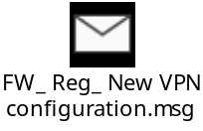
HB | Mon 7/10/2023 9:45 AM | RE: El Paso - Sale Median value Clarification | Confirmation received from Avinash for sales Median Value  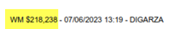 | 
HB | Wed 7/12/2023 10:03 AM | RE: Reg - Sale Price(BUS VALUE) - Confirmation | For Travis CAD, (salesPrice Bus Value)  Sale Price Calculation Sale price = Bus Value – 17% | 
HB | Thu 7/13/2023 6:10 PM | RE: 304922 EVIDENCE | To open Error PDF - https://www.ilovepdf.com/repair-pdf | 